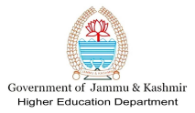
OFFICE OF THE PRINCIPAL
SHAHEED GHANISHAM
GOVT DEGREE COLLEGE DOONGI, RAJOURI-185151
Dated: 26 / 06 /2023

SG Govt. Degree College Doongi Commemorates International Day Against Drug Abuse 2023 with a Focus on "People First: Stop Stigma and Discrimination, Strengthen Prevention"
SG Govt. Degree College Doongi organized a significant event on June 26, 2023, to commemorate International Day Against Drug Abuse. The program, jointly coordinated by Prof. Samina Khan, Convener of the Red Ribbon Club, Prof. Zaheer Abass, NSS Programme Officer, and Prof. Naresh Kumar, Convener of Shikshit Bharat, aimed to raise awareness about the impact of drug abuse and the importance of creating a supportive and inclusive environment for individuals struggling with addiction. The theme for this year's International Drug Abuse Day was "People First: Stop Stigma and Discrimination, Strengthen Prevention." One of the highlights of the event was the detailed lecture delivered by Prof. Zaheer Abass, who shed light on various aspects related to the theme. His comprehensive talk provided valuable insights into the detrimental effects of stigma and discrimination faced by individuals battling drug addiction. He emphasized the need for a compassionate and empathetic approach towards those affected, highlighting the importance of reducing social barriers and fostering a supportive environment. The program also included interactive session conducted by the Red Ribbon Club, NSS, and Shikshit Bharat. These activities aimed to educate the college community about prevention strategies, the role of community support, and the significance of early intervention in tackling drug abuse.
The whole event was organized under the Patronship of Dr. Jaipal Singh, Principal of SG Govt. Degree College Doongi. The event concluded with a pledge taken by the students and faculty members to promote a drug-free society, eliminate stigma and discrimination, and strengthen preventive measures. The college reiterated its commitment to continue organizing such initiatives and spreading awareness to combat the global challenge of drug abuse.
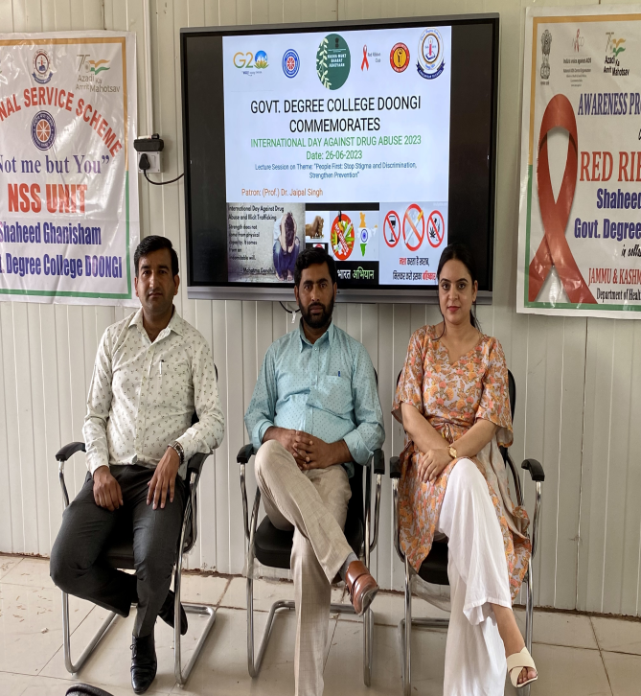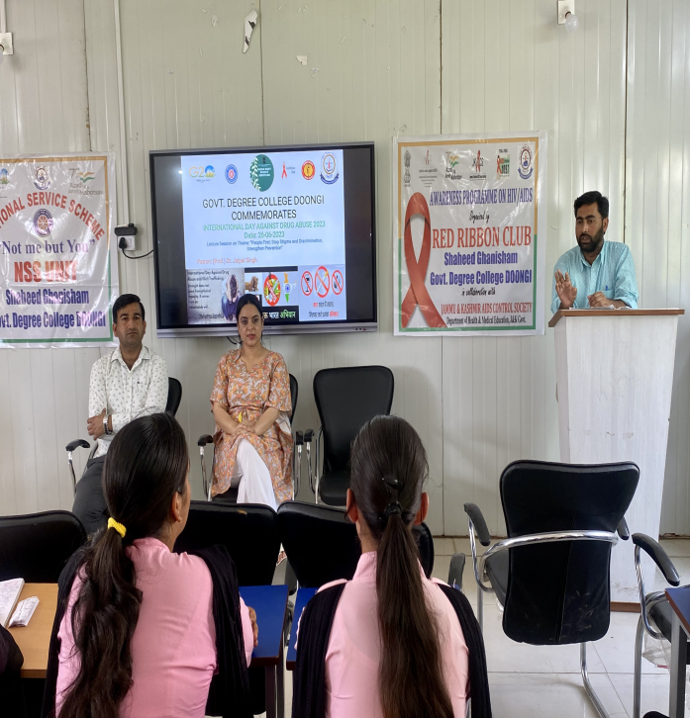

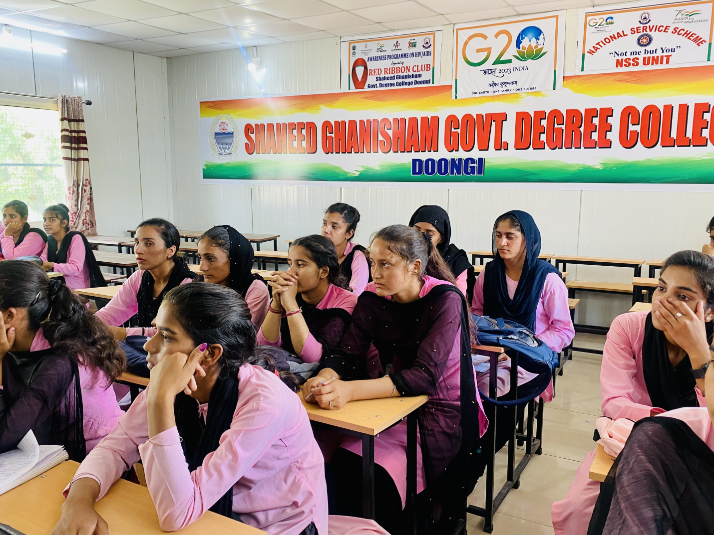

Sd/-
Principal,

